- DOWNLOADED THE GIT AND RUNNED IT SUCCESFULLY
Install git {sudo yum install git -y}
Started by {git init}
Checked status by {git status}
Checked version {git -version}
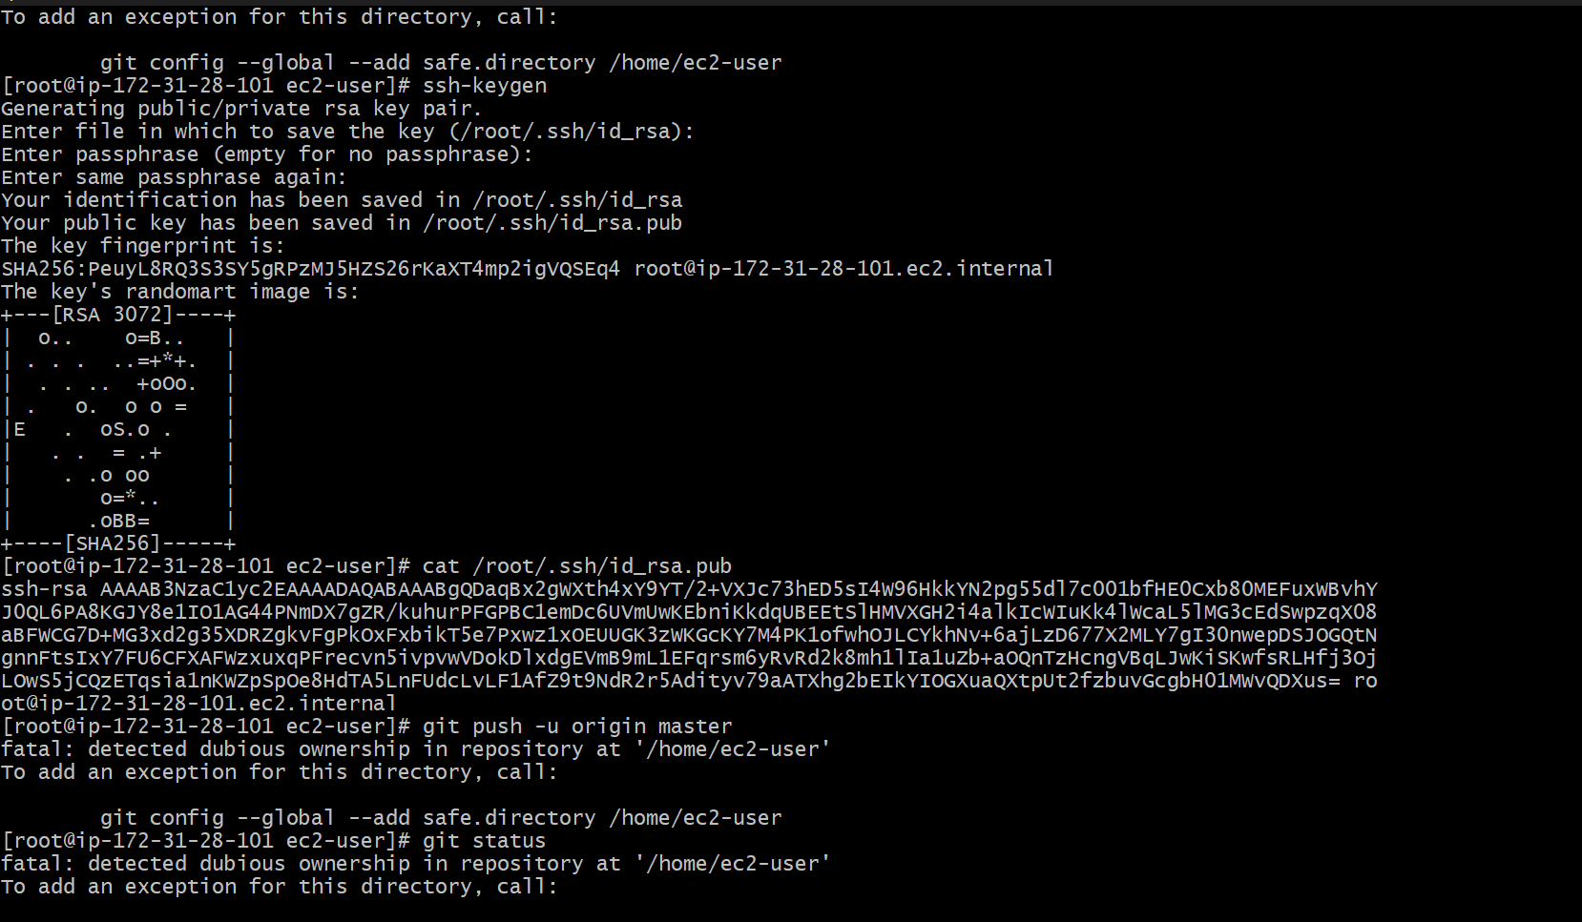
Checked version
Then checked config {git config --list}
Then added username {git config --global username.name””}
Then username {git config --global user.email””}
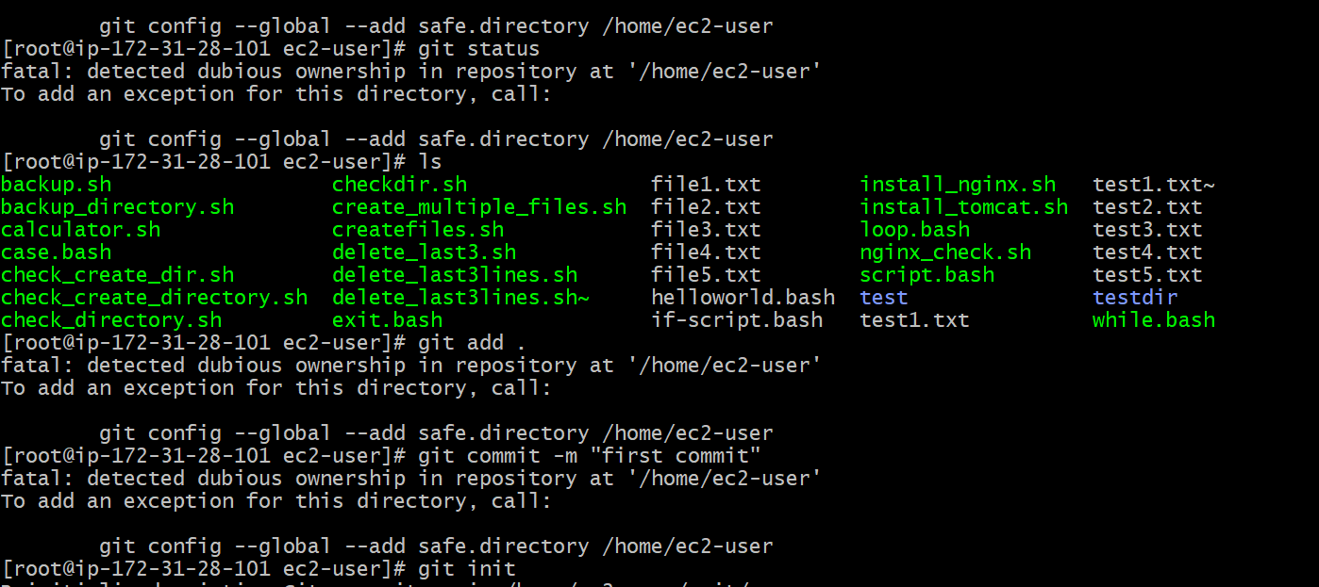
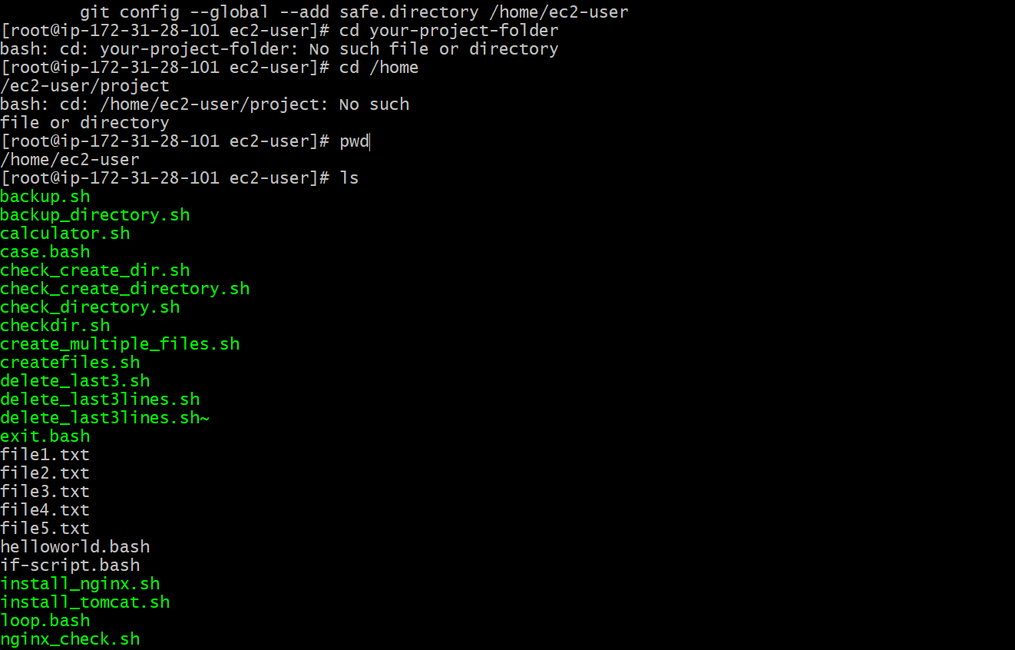
Used some commands here
Git commit -m
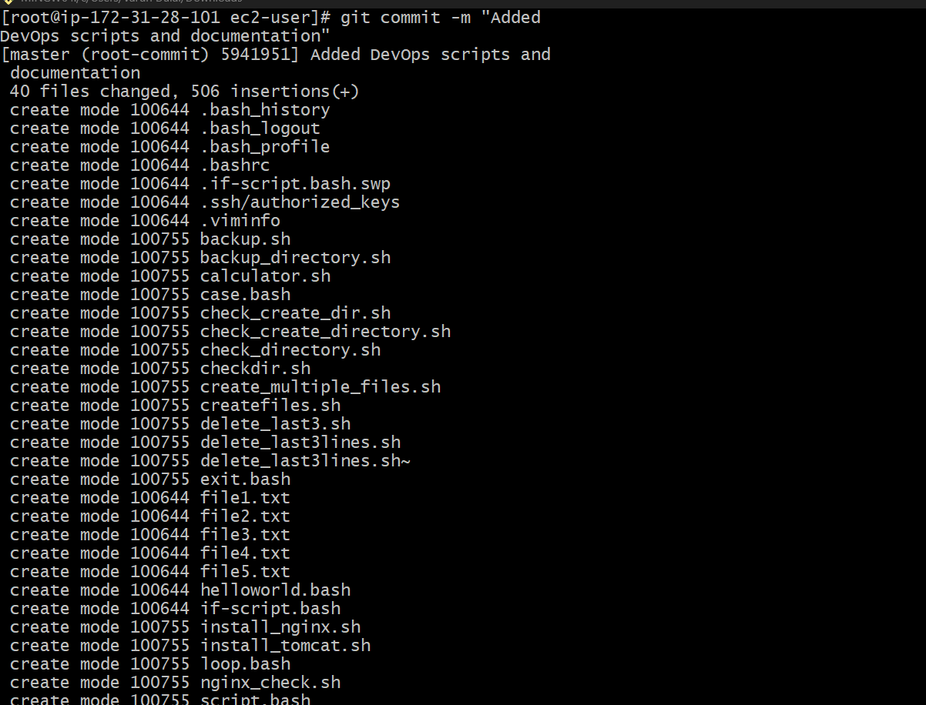
Used commands here
Git branch -M main
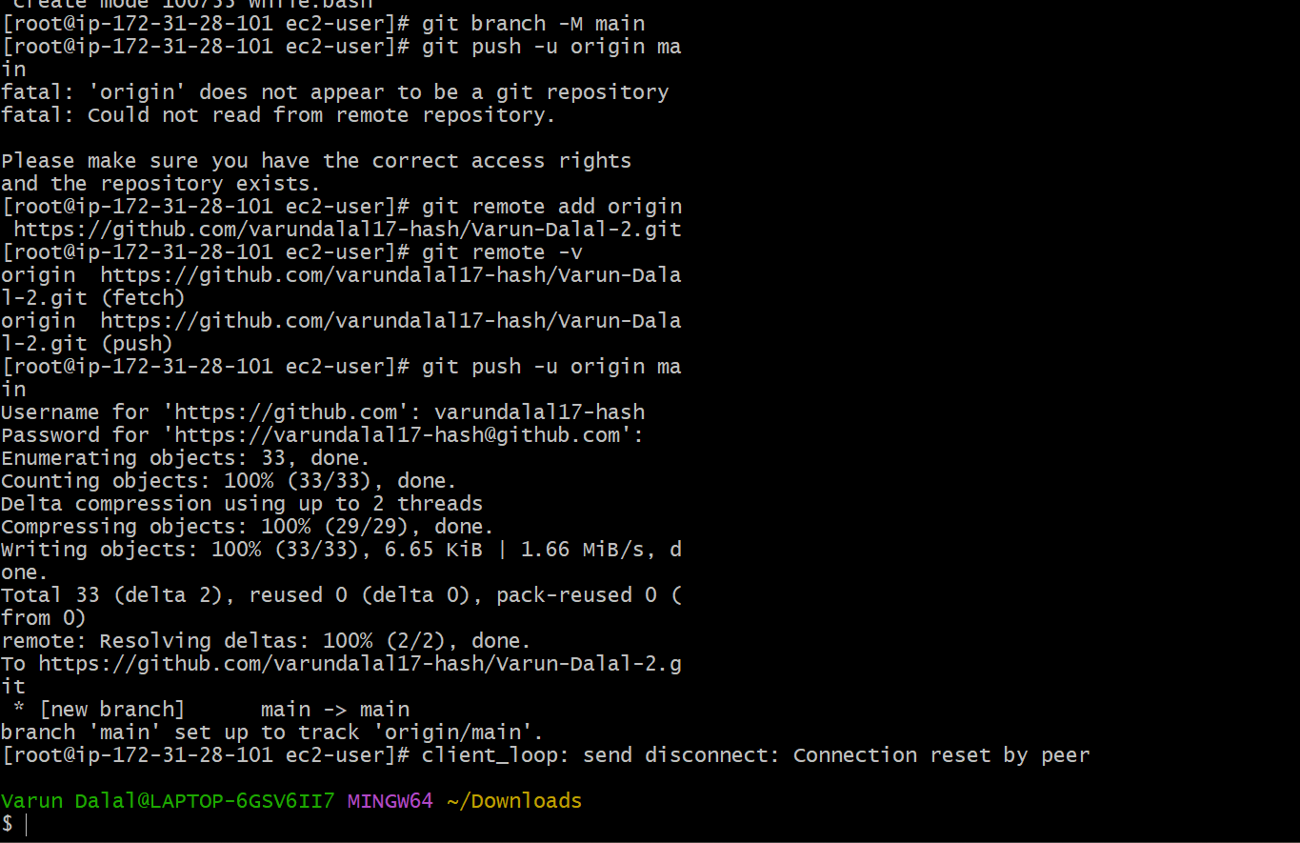
Created all the files in git hub
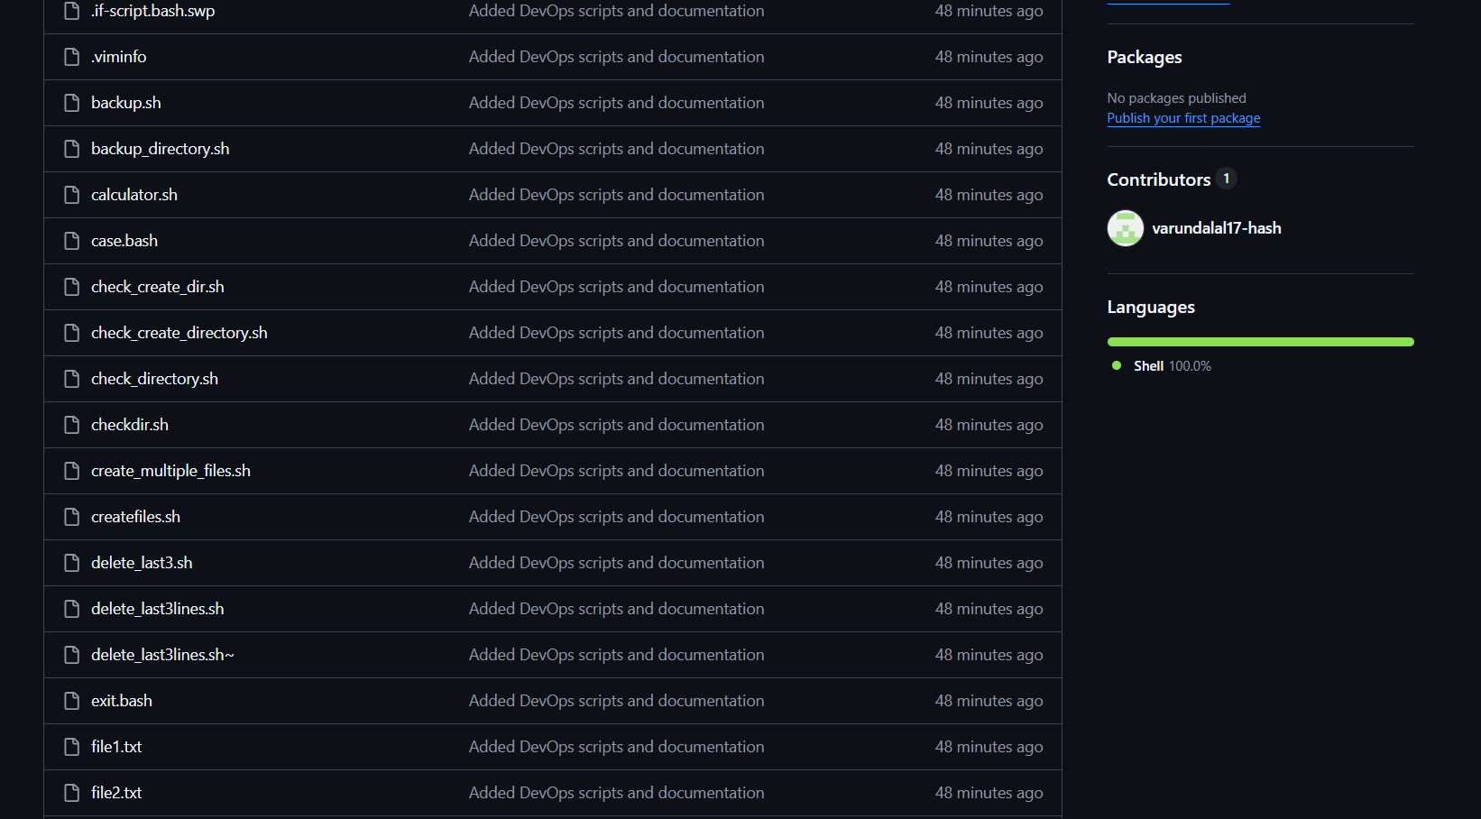

Done with two factor authentication
